

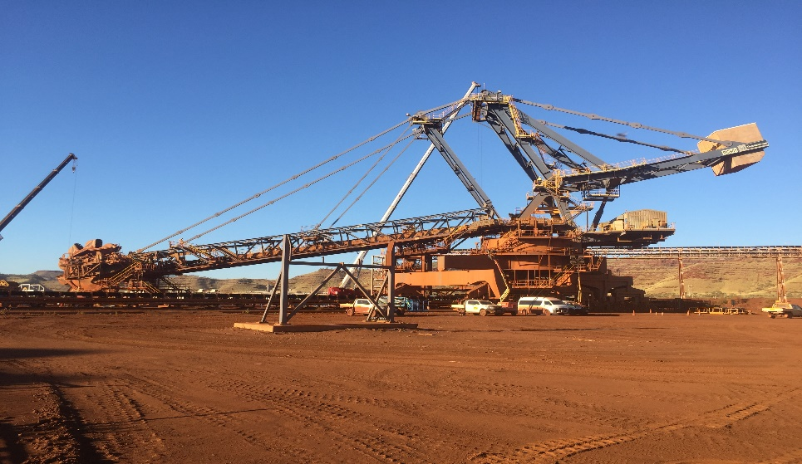

**Solomon Firetail Reclaimer RC901**

**1 Y MRMP RC901 Inspect Luff System Report**

**Work Order: 2200886096**

**Document: BMS-03-REP-056_ILS-MRMP**

**Document Revision**

|  |  |  |  |  |
| --- | --- | --- | --- | --- |
| **Rev** | **Date** | **Prepared** | **Approved** | **Comments** |
| 0 | 18/10/2024 | RS | DR | Client Review |
|  |  |  |  |  |

**Balance Machine Services**

ABN: 18 663 508 576

<https://bmservices.com.au/>

Unit 1, 64 Baile Rd

Canning Vale WA 6155

Contact: [planning@bmservices.com.au](mailto:planning@bmservices.com.au)

**CONTENTS**

1 Job / Scope Description 3

2 Scope of Inspection 3

3 Disclaimers and Limitations 3

4 Inspected Items 4

4.1 Item 1 Reclaimer RC901 Boom Luffing Cylinder 4

4.2 Item 2 Reclaimer RC901 Boom Luffing Power Unit GA 4

4.2 Item 3 Reclaimer RC901 Boom Luffing Hydraulic Circuit 5

5 Inspection Results 6

5.1 Defect 1 6

5.2 Defect 2 7

5.3 Defect 3 8

6 Infield Checklist 9

Appendices 17

Appendix 1. Risk Matrix 17

# Job / Scope Description

Balance Machine Services (BMS) were tasked to complete inspections on RC901 Luff System, on the recent SY24TL09 Firetail shutdown at Solomon.

# Scope of Inspection

This checklist is to provide FMG with the information required to perform a Luff System inspection on Solomon Reclaimer RC901. The checklist is to be used in conjunction with Solomon Reclaimer RC901 12 monthly Luff System Offline Inspection procedure (SO-08009-PR-ME-0006).

The inspection is to be carried out by a competent Mechanical Inspector with tradesman as required and will take 12 hours to complete. This inspection checklist describes the offline “MRMP” inspections tasks required to ensure the luff system does not pose a risk to the machine structural integrity.

The offline checks are complemented by online checks that ensure the system is operating correctly in accordance with the machine design requirements. Online inspection checks are outlined separately in an online checklist procedure.

The primary objective of this work is to enable reporting on the luff system and luff cylinder condition and serviceability, noting any defects and corrective action that may be required to prolong the life span of this equipment.

# Disclaimers and Limitations

BMS inspections were completed as per FMG MRMP Luff system Inspection procedure (SO-08009-PR-ME-0006).

The scope of supply and services for machine inspections is limited only to a visual inspection of the Luff cylinder and HPU components of the plant / machine being the subject of this report. In performing a visual inspection, it is not possible to identify all defects in the components and steel structures.

Some (but not all) of the factors limiting the effectiveness of the inspection are: Defects could develop in non-visible areas of the plant / machine.

Defects could be covered by paint, dust, dirt, material build up, lubricants or a combination thereof.

Some defects may not have propagated to the surface of the relevant component and may therefore not be visible.

In light of the above, BMS offer no warranty or indemnity whatsoever to the client that the inspection will result in the detection or identification of all or any existing or possible defects in the inspected plant/machine.

# Inspected Items

## Item 1 Reclaimer RC901 Boom Luffing Cylinder

Figure 1 – Luff Cylinders

## Item 2 Reclaimer RC901 Boom Luffing Power Unit GA

## Item 3 Reclaimer RC901 Boom Luffing Hydraulic Circuit

# Inspection Results

## Defect 1

|  |  |  |  |  |  |  |  |  |  |  |  |
| --- | --- | --- | --- | --- | --- | --- | --- | --- | --- | --- | --- |
| **Defect Reference & Location** | | | | | | **SAP Equipment Identification** | | | | | |
| **Inspection Date:** | 29/09/2024 | | | | | **FLOC:** | | Planner use if not known | | | |
| **Defect Title:** | Luff Cylinder gland leaking | | | | | **Equip:** | | Planner use if not known | | | |
| **WO Ref:** | 2200886096 | | | | | **Assy:** | | Planner use if not known | | | |
| **Defect ID:** | WO# 2200886096 | | | | | **Equip / Tag Number:** | |  | | | |
| **Defect Location Description:** | Luff cylinder on the right (direction of the belt) is leaking. | | | | | | | | | | |
|
|  | | | | |  | | | | | | |
| **Defect Description** | | | | | | | | | | | |
| The luff cylinders come manufactured with 4 chevron seals installed. RC901 right cylinder started leaking on the gland getting worse over time. FMG ordered to have 2 shims removed with the current state still have 2 shims in place. The leak after inspection is becoming worse as seen on the photos attached. | | | | | | | | | | | |
| **Defect Risk Assessment (See Risk Matrix)** | | | | **Attachments Incl:** | | |  | | **Number of Pages:** | |  |
| **Failure Probability:** | | 1/10year | | **SAP Cause Code:** | | |  | | | | |
| **Potential Consequence:** | | Major | | **SAP Damage Code:** | | |  | | | | |
| **Risk Rating:** | | **4** | | **SAP Priority Code:** | | |  | | | | |
| **Defect Repair Requirements** | | | | | | | | | | | |
| Describe what is required to repair the defect. Consider:  a) 12 hrs to remove and clean the cylinder gland cover and seal. b) Replacement of the chevron seals and installing 4 shims. c) 1 x mechanical trade with the other person a qualified hydraulic technician. d) Chevron seal kit is required. Rags, buckets, hand tools spanner set 10 – 24 mm, Socket set, Spill kit, cable ties. | | | | | | | | | | | |
| **Repair Operational Status:** | | |  | | | **Scaff / EWP Required:** | | | | 135 Foot | |
| **Repair Duration Estimate (hours):** | | | **12 Hrs** | | | **Crane Required:** | | | | No | |
| **Repair Labour Type:** | | | Hyd Trade | | | **Special Tooling / Parts:** | | | |  | |

## Defect 2

|  |  |  |  |  |  |  |  |  |  |  |  |
| --- | --- | --- | --- | --- | --- | --- | --- | --- | --- | --- | --- |
| **Defect Reference & Location** | | | | | | **SAP Equipment Identification** | | | | | |
| **Inspection Date:** | 29/09/2024 | | | | | **FLOC:** | | Planner use if not known | | | |
| **Defect Title:** | Balance line valves | | | | | **Equip:** | | Planner use if not known | | | |
| **WO Ref:** | 2200886096 | | | | | **Assy:** | | Planner use if not known | | | |
| **Defect ID:** | WO# 2200886096 | | | | | **Equip / Tag Number:** | |  | | | |
| **Defect Location Description:** | Luff cylinder balance lines to be fitted with locks to prevent uncontrolled operation of valves. | | | | | | | | | | |
|
|  | | | | |  | | | | | | |
| **Defect Description** | | | | | | | | | | | |
| The luff cylinders have balance lines installed with 2 x ball valves to equalize the hydraulic pressures between the top and bottom of both the hydraulic cylinders. The ball valves were identified not to have lock fitted to them preventing uncontrolled operation of the valves. | | | | | | | | | | | |
| **Defect Risk Assessment (See Risk Matrix)** | | | | **Attachments Incl:** | | |  | | **Number of Pages:** | |  |
| **Failure Probability:** | | 1/10year | | **SAP Cause Code:** | | |  | | | | |
| **Potential Consequence:** | | Minor | | **SAP Damage Code:** | | |  | | | | |
| **Risk Rating:** | | **1** | | **SAP Priority Code:** | | |  | | | | |
| **Defect Repair Requirements** | | | | | | | | | | | |
| Describe what is required to repair the defect. Consider:  a) 1 hr to prepare paperwork. b) Installation of 2 x locks c) 1 x mechanical trade. d) 2 x approved locks. | | | | | | | | | | | |
| **Repair Operational Status:** | | |  | | | **Scaff / EWP Required:** | | | | No | |
| **Repair Duration Estimate (hours):** | | | **1 Hrs** | | | **Crane Required:** | | | | No | |
| **Repair Labour Type:** | | | Trade | | | **Special Tooling / Parts:** | | | | No | |

## Defect 3

|  |  |  |  |  |  |  |  |  |  |  |  |
| --- | --- | --- | --- | --- | --- | --- | --- | --- | --- | --- | --- |
| **Defect Reference & Location** | | | | | | **SAP Equipment Identification** | | | | | |
| **Inspection Date:** | 29/09/2024 | | | | | **FLOC:** | | Planner use if not known | | | |
| **Defect Title:** | Hydraulic HPU | | | | | **Equip:** | | Planner use if not known | | | |
| **WO Ref:** | 2200886096 | | | | | **Assy:** | | Planner use if not known | | | |
| **Defect ID:** | WO# 2200886096 | | | | | **Equip / Tag Number:** | |  | | | |
| **Defect Location Description:** | Luff cylinder HPU have 2 pressure filters installed, only one filter was supplied and changed. | | | | | | | | | | |
|
| A close-up of a machine | | | | |  | | | | | | |
| **Defect Description** | | | | | | | | | | | |
| The luff cylinders HPU have 2 filters installed, one will be used in normal operation and the other is on standby. Both these filters are crucial for the correct operation of the luffing system. | | | | | | | | | | | |
| **Defect Risk Assessment (See Risk Matrix)** | | | | **Attachments Incl:** | | |  | | **Number of Pages:** | |  |
| **Failure Probability:** | | 1/10year | | **SAP Cause Code:** | | |  | | | | |
| **Potential Consequence:** | | Serious | | **SAP Damage Code:** | | |  | | | | |
| **Risk Rating:** | | **3** | | **SAP Priority Code:** | | |  | | | | |
| **Defect Repair Requirements** | | | | | | | | | | | |
| Describe what is required to repair the defect. Consider:  a) 2 hrs to complete the task b) Installation of 2 x Pressure filters c) 2 x mechanical trade. d) 2 x HYDAC Pressure filters. | | | | | | | | | | | |
| **Repair Operational Status:** | | |  | | | **Scaff / EWP Required:** | | | | No | |
| **Repair Duration Estimate (hours):** | | | **2 Hrs** | | | **Crane Required:** | | | | No | |
| **Repair Labour Type:** | | | Trade | | | **Special Tooling / Parts:** | | | | No | |

# Infield Checklist

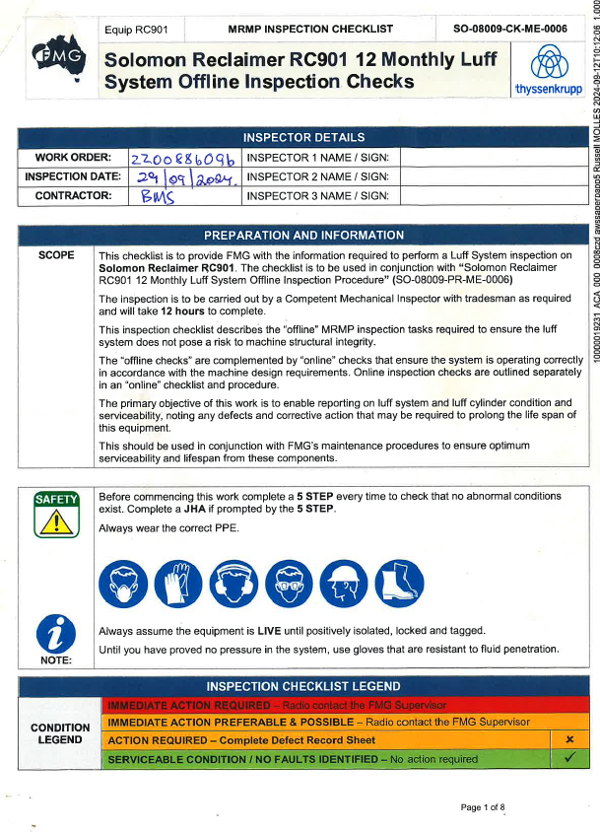

# Appendices

#### Risk Matrix

Table 2 -- Risk Matrix

|  |  |  |  |  |  |  |  |
| --- | --- | --- | --- | --- | --- | --- | --- |
|  | | | **Consequence** | | | | |
| **1 - Minor** | **2 - Medium** | **3 - Serious** | **4 - Major** | **5 - Extreme** |
| **Probability** | **Risk Frequency** | **Risk Descriptor** | **FAI $10k - $100k** | **MTI $100k - $500k** | **RWI $500k - $2M** | **LTI $2M - $20M** | **Fatality > $20M** |
| 1/week | A - Almost Certain | Moderate | High | Extreme | Extreme | Extreme |
| 1/month | B - Likely | Moderate | High | High | Extreme | Extreme |
| 1/year | C - Possible | Low | Moderate | High | High | Extreme |
| 1/10 years | D - Unlikely | Low | Low | Moderate | High | High |
| 1/100 years | E - Rare | Low | Low | Low | Moderate | High |

FAI - First Aid Injury: An injury that requires basic first aid treatment, usually minor and not requiring medical intervention.

MTI - Medical Treatment Injury: An injury that requires medical treatment beyond first aid but is not life-threatening.

RWI - Restricted Work Injury: An injury that results in the employee being unable to perform their normal work duties for a period of time, but not resulting in a permanent disability.

LTI - Lost Time Injury: An injury that results in an employee being unable to work for at least one full shift or day.